A
PROJECT REPORT
ON
"Cyber Quest: A Gamified Cybersecurity Learning and Assessment Platform"
BACHELOR OF TECHNOLOGY
IN
COMPUTER SCIENCE AND ENGINEERING (CYBERSECURITY)
BY
B. BHAVITHA – 24N81A6215
CH. BHAVANA – 24N81A6216
V. MOUNIKA – 24N81A6218
B. AARTHIKA – 24N81A6255
Under the Guidance of
Mrs. A. Sandhya Rani
Assistant Professor
Department of CSE (CYBER SECURITY)


DEPARTMENT OF COMPUTER SCIENCE AND ENGINEERING (CS) SPHOORTHY ENGINEERING COLLEGE
Nadergul (Vill.), Near L.B. Nagar, Hyderabad, Telangana – 501510.
[2024-2028]

SPHOORTHY ENGINEERING COLLEGE
DEPARTMENT OF COMPUTER SCIENCE AND ENGINEERING (CS)

CERTIFICATE
This is to certify that this Project Based learning Report entitled "CyberQuest: A Gamified Cybersecurity Learning and Assessment Platform" is a Bonafide work carried out by Bhavitha (215) , Bhavana(216),Mounika(218),Aarthika(255) in partial fulfilment of the requirements for the award of degree of Bachelor of Technology in Computer Science and Engineering (CS) from Sphoorthy Engineering College, affiliated to Jawaharlal Nehru Technological University Hyderabad, during the Academic Year 2025-26 under our guidance and supervision.
The results embodied in this report have not been submitted to any other university or institute for the award of any degree or diploma.

Internal Guide Head of the Department
Mrs. A.Sandhya Rani
Assistant Professor
Department of CSE (CS) SPHN

DECLARATION
We the undersigned, project based learning Report "CyberQuest: A Gamified Cybersecurity Learning and Assessment Platform" carried out at “SPHOORTHY ENGINEERING COLLEGE” is original and is being submitted to the Department of COMPUTER SCIENCE AND ENGINEERING (CYBERSECURITY), Sphoorthy Engineering College, Hyderabad towards partial fulfilment for the award of degree of Bachelor of Technology.
We declare that the result embodied in the the PBL Report has not been submitted to any other University or Institute for the award of any Degree or Diploma.
Date:
Place:
GROUP MEMBERS:
B. BHAVITHA – 24N81A6215
CH. BHAVANA – 24N81A6216
V. MOUNIKA – 24N81A6218
B. AARTHIKA – 24N81A6255

ACKNOWLEDGEMENT
We sincerely thank our Project Guide Mrs. A. Sandhya Rani, Asst. Professor, Department of Computer Science & Engineering (CYBERSECURITY), Sphoorthy Engineering College, for her inspiring guidance, consistent encouragement, constructive criticism and helpful suggestions during the entire course of my project work.
We express our sincere thanks to Mrs. P. Sandhya Rani, Professor & Head of the Department, Department of Computer Science & Engineering (CS), Sphoorthy Engineering College, Nadergul (V), Balapur (M), Ranga Reddy (D) for their encouragement which helped us to complete the Project work.
We deem it a great privilege to express our profound gratitude and sincere thanks to Mr. S. Chalama Reddy, Chairman, Mr. S. Jagan Mohan Reddy, Secretary, Dr. K. Srinivas Rao, Principal, Sphoorthy Engineering College, Nadergul (V), Balapur (M), Ranga Reddy (D), for their moral support and help in the completion of the project work.
We express our heartfelt thanks to Professors, Associate Professors, Assistant Professor and other professional non-teaching staff of Department of Computer Science and Engineering (CS), Sphoorthy Engineering College, Nadergul (V), Balapur (M), Ranga Reddy (D) for providing the necessary information pertaining to our project work.
BATCH: 2024 – 2028
GROUP MEMBERS:
B. BHAVITHA – 24N81A6215
CH. BHAVANA – 24N81A6216
V. MOUNIKA – 24N81A6218
B. AARTHIKA – 24N81A6255

ABSTRACT
CyberQuest: A Gamified Cybersecurity Learning and Assessment Platform is a web-based application designed to improve cybersecurity awareness through interactive quizzes and learning activities. The platform helps users understand important cybersecurity concepts such as phishing, malware, password security, network security, and ethical hacking in an engaging manner.
The system allows users to register, log in, attempt quizzes, and view their scores and performance. It is developed using HTML, CSS, JavaScript, Node.js, Express.js, and MongoDB, providing a secure and user-friendly environment for learning and assessment.
The main objective of this project is to make cybersecurity education more interactive and accessible by combining learning with gamification techniques. The platform enables users to test their knowledge, identify areas for improvement, and enhance their understanding of digital security concepts.
The project addresses the challenge of limited cybersecurity awareness among students by providing a centralized platform for learning and self-assessment. Users can evaluate their understanding of cybersecurity concepts, identify areas for improvement, and track their progress over time
Overall, CyberQuest serves as an effective learning tool that promotes cybersecurity awareness and helps users develop essential skills required for safe and responsible use of technology.

GROUP MEMBERS:
B. BHAVITHA – 24N81A6215
CH. BHAVANA – 24N81A6216
V. MOUNIKA – 24N81A6218
B. AARTHIKA – 24N81A6255

I

INDEX
II
Contents |  |  | Page No.
Abstract |  |  | I
Index |  |  | II
List of Figures |  |  | III
CHAPTERS
1. | Introduction |  | 1
 | 1.1 | Problem Statement | 1
 | 1.2. | Objective | 1
 | 1.3. | Existing System | 1
 | 1.4. | Proposed System | 2
 | 1.5. | Scope | 2
 | 1.6. | Software & Hardware Requirements | 3
2. | Literature Survey |  | 4
 | 2.1. | Survey of Major Area Relevant to Project | 4
 | 2.2. | Techniques and Algorithms | 5
 | 2.3. | Applications | 5
3. | System Design |  | 6
 | 3.1. | System Architecture | 6
 | 3.2. | System Flow | 7
 | 3.3. | Module Description | 7
 | 3.4. | UML Diagram | 8
4. | Implementation |  | 13
 | 4.1. | Environmental Setup | 13
 |  | 4.1.1 Development Environment | 13
 | 4.2. | Implementation of Modules | 14
 | 4.3. | Integration and Development | 14
5. | Evaluation |  | 15
 | 5.1. | Modules | 15
 | 5.2. | Evaluation Metrics | 17
 | 5.3. | Test Cases | 16
 | 5.4 | Results | 23
6. | Conclusion and Future Enhancement |  | 24
 | References |  | 25
 | Appendix and Sample code |  | 27

LIST OF FIGURES
Figure No. | Figure Name | Page No.
3.2.1 | Use Case Diagram | 8
3.2.2 | Class Diagram | 10
3.2.3 | Sequence Diagram | 10
3.2.4 | Activity Diagram | 12
5.3.1 | Welcome module page | 18
5.3.2 | Registration | 19
5.3.3 | Login page | 20
5.3.4 | Quiz assessment module | 21
5.3.5 | Evalutaion and result | 22
5.3.6 | Performance dashboard | 23

III

CHAPTER-1
INTRODUCTION
  - PROBLEM STATEMENT
Many students and internet users lack adequate cybersecurity awareness and knowledge about online threats such as phishing attacks, malware, weak passwords, and social engineering. Traditional learning methods are often theoretical and less engaging, making it difficult for users to retain important cybersecurity concepts. There is a need for an interactive platform that makes cybersecurity education more accessible, interesting, and effective. The CyberQuest platform addresses this issue by providing a gamified quiz-based learning environment that promotes cybersecurity awareness and knowledge assessment.
  - OBJECTIVE
The objective of CyberQuest is to develop a web-based platform that enhances cybersecurity awareness through interactive quizzes and gamification techniques. The system aims to help users learn important cybersecurity concepts in an engaging manner while evaluating their knowledge through assessments. It provides a secure and user-friendly environment for learning, performance tracking, and self-improvement. The platform encourages continuous learning and helps users develop essential cybersecurity skills required in today's digital world.
  - EXISTING SYSTEM
Currently, cybersecurity education is mainly provided through textbooks, online articles, video tutorials, and training courses. These resources often lack interactivity and do not effectively measure users' understanding of cybersecurity concepts. Learning from multiple sources can be time-consuming and may reduce user engagement. Most traditional systems do not provide instant feedback or performance tracking. As a result, users may find it difficult to assess their knowledge and identify areas for improvement.
Drawbacks:
- Limited user engagement and interaction.
- Lack of real-time assessment and feedback.
- Difficult to track learning progress.
- Learning resources are scattered across multiple platforms.
- Lower knowledge retention compared to interactive learning methods.

  - PROPOSED SYSTEM
The proposed system, CyberQuest: A Gamified Cybersecurity Learning and Assessment Platform, is designed to provide an interactive and engaging environment for cybersecurity education. The platform allows users to register, log in, participate in cybersecurity quizzes, and receive instant feedback on their performance. It covers various cybersecurity topics such as phishing, malware, password security, network security, cryptography, and ethical hacking.
Key Features of Proposed System
- User Registration and Secure Login
- Interactive Cybersecurity Quizzes
- Instant Score Calculation and Results
- Performance Tracking and Assessment
- User-Friendly Interface
- Secure Data Storage using MongoDB
Working of the System
- User registers and logs into the platform.
- User selects and starts a cybersecurity quiz.
- System displays questions related to cybersecurity concepts.
- User submits answers for evaluation.
- System calculates the score and generates results.
- User can view performance and track learning progress.
  - SCOPE
- Enhances cybersecurity awareness and knowledge among students and internet users.
- Provides an interactive platform for learning cybersecurity concepts through quizzes.
- Helps users assess their understanding of various cybersecurity topics.
- Encourages continuous learning and skill development in the field of cybersecurity.

Applications:
- Cybersecurity awareness and training programs.
- Educational institutions and learning platforms.
- Student skill assessment and knowledge evaluation systems.
- Online cybersecurity learning and certification preparation.

Future Scope:
- Integration of AI-based adaptive quiz generation.
- Implementation of difficulty levels (Easy, Medium, Hard).
- Addition of leaderboards, badges, and reward systems.
- Development of a mobile application version for wider accessibility.
- Integration of real-world cybersecurity simulations and learning resources.

  - SOFTWARE AND HARDWARE REQUIREMENTS
Software Requirements
- Operating System: Windows 10 / Windows 11
- Frontend Technologies: HTML, CSS, JavaScript
- Backend Technology: Node.js, Express.js
- Database: MongoDB
- IDE / Code Editor: Visual Studio Code
- Web Browser: Google Chrome / Microsoft Edge
- Version Control: Git
Hardware Requirements
- RAM: 4 GB (Minimum), 8 GB Recommended
- Storage: 50 GB Free Disk Space (Minimum)
- System Type: 64-bit Operating System, x64-based Processor
- Processor: Intel Core i3 / Intel Core i5 or equivalent AMD processor (Minimum 2.0 GHz)

CHAPTER-2
LITERATURE SURVEY

2.1 SURVEY OF MAJOR AREA RELEVANT TO PROJECT

The project covers multiple important areas in computer science and security:
Cybersecurity Awareness Systems
Cybersecurity awareness systems are designed to educate users about online threats, security risks, and safe internet practices. These systems help users understand concepts such as phishing, malware, password security, and data protection. They play an important role in reducing cyber risks by improving user awareness.
Online Learning Platforms
Online learning platforms provide educational content through digital technologies. They allow users to access learning materials, assessments, and interactive activities from anywhere. Such platforms improve accessibility and promote self-paced learning.
Quiz-Based Learning Systems
Quiz-based learning systems use assessments and interactive questions to enhance knowledge retention and evaluate user understanding. These systems provide instant feedback and help learners identify their strengths and weaknesses. They are widely used in educational and training environments.
Gamification in Education
Gamification involves applying game-like elements such as points, rewards, levels, and achievements to educational systems. It increases user engagement, motivation, and participation. Gamified learning environments make the learning process more interactive and enjoyable.
User Authentication and Data Management Systems
Authentication and data management systems ensure secure access to applications and proper storage of user information. These systems help protect user data, manage accounts, and maintain the integrity of application resources.

2.2 TECHNIQUES AND ALGORITHMS
User Authentication Technique
User authentication is used to verify user credentials during registration and login. It ensures that only authorized users can access the platform and their quiz records.
Quiz Evaluation Technique
This technique is used to compare user answers with the correct answers stored in the database. It helps in evaluating user performance accurately and efficiently.
Score Calculation Technique
The score calculation technique is used to calculate the total marks obtained by the user based on correct answers. The final score is displayed after quiz completion.
Session Management Technique
Session management is used to maintain user login status and provide secure access to different modules of the platform during a session.
Database Management Technique
MongoDB is used to store user information, quiz questions, scores, and results. This technique helps in efficient data storage, retrieval, and management.

2.3 APPLICATIONS
CyberQuest is used for cybersecurity awareness, online learning, knowledge assessment, and skill development. It helps students and internet users understand cybersecurity concepts through interactive quizzes and instant feedback. The platform can be used in educational institutions, training programs, and cybersecurity awareness initiatives to improve digital security knowledge.

CHAPTER-3
SYSTEM DESIGN
The CyberQuest system follows a client-server architecture where users interact with the web application through a browser. The frontend provides an interactive interface for registration, login, quizzes, and result viewing. The backend processes user requests, validates quiz responses, calculates scores, and communicates with the database. MongoDB stores user details, quiz questions, scores, and performance records. The system ensures secure authentication and efficient data management while providing a smooth learning experience.
3.1 SYSTEM ARCHITECTURE
The system follows a user-centered architecture where the user interacts with the web interface to enter rank details and complete assessments. The backend processes the information and generates career and college recommendations. The database stores user data, technology information, and recommendation details.

Simple Architecture Flow:
┌─────────────┐
│ USER │
└──────┬──────┘
│
▼
┌───────────────────────┐
│ WEB INTERFACE │
│ HTML, CSS, JavaScript│
└───────────┬───────────┘
│
▼
┌───────────────────────┐
│ BACKEND │
│ Node.js + Express.js │
└───────────┬───────────┘
│
▼
┌───────────────────────┐
│ MONGODB DATABASE │
└───────────┬───────────┘
│
▼
┌───────────────────────┐
│ QUIZ EVALUATION AND │
│ SCORE CALCULATION │
└───────────┬───────────┘
│
▼
┌───────────────────────┐
│ RESULTS & PERFORMANCE │
│ DASHBOARD │
└───────────────────────┘
3.2 SYSTEM FLOW
Step-by-step working flow:
Step 1: The user opens the CyberQuest application.
Step 2: The user registers a new account or logs into the system.
Step 3: The system verifies the user credentials.
Step 4: The user selects a cybersecurity quiz.
Step 5: The system displays quiz questions to the user.
Step 6: The user submits answers after completing the quiz.
Step 7: The system evaluates answers and calculates the score.
Step 8:The final score and performance details are displayed.
Step 9 : The quiz results are stored in the database.
Step 10 : The user exits the system after completing the assessment.
3.3 MODULE DESCRIPTION
The system consists of the following modules:
1. User Registration Module
This module allows new users to create an account on the CyberQuest platform.
2. User Login Module
This module authenticates registered users and provides access to the platform
3. Quiz Module
This module presents cybersecurity questions to users.
4. Score Module
This module calculates scores based on user responses
5. Results Module
This module displays the final quiz results.
6. Database Module
This module manages application data and user records.
3.4 UML DIAGRAM

1. Use Case Diagram
Actors: Student / User, Admin
Use Cases:
- User Registration
- User Authentication
- Cybersecurity Quiz Assessment
- Score Calculation and Feedback
- Results Generation
- Performance Monitoring Dashboard
- Quiz Management (Admin)
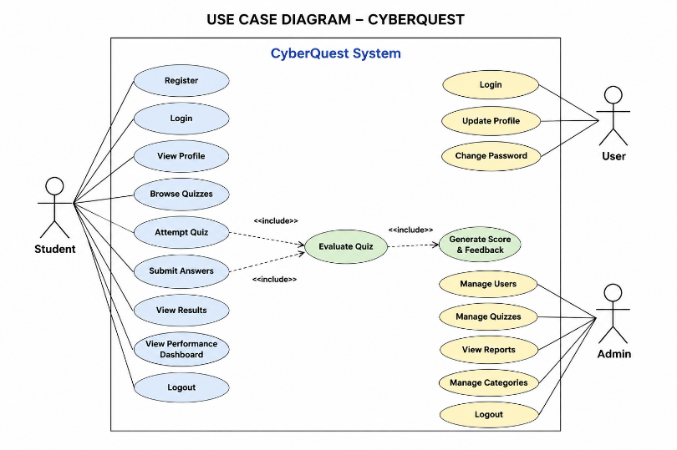
Fig 3.2.1 Use Case Diagram
2. Class Diagram
Main Classes:
Classes
User
- User ID
- Username
- Email
- Password
- Register()
- Login()
2. Quiz
- Quiz ID
- Questions
- Options
- Correct Answers
- StartQuiz()
- SubmitQuiz()
3. Result
- Score
- Performance Level
- CalculateScore()
- GenerateResult()
4. Dashboard
- User Score
- Progress Status
- ViewPerformance()
5. Admin
- Admin ID
- ManageUsers()
- ManageQuiz()
- GenerateReports()
6. Database
- StoreData()
- RetrieveData()
- UpdateData()
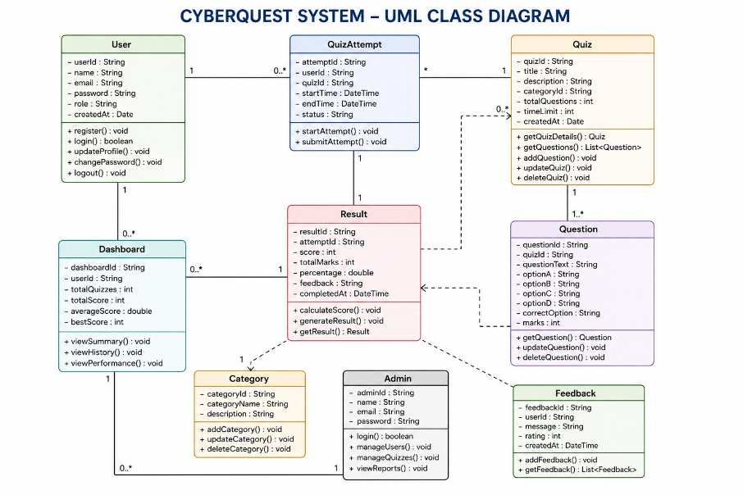
Fig 3.2.2 Class Diagram

- Sequence Diagram (Login & Access Control)
- User enters email and password.
- Login Page sends credentials to Authentication Controller.
- Authentication Controller verifies credentials with Database.
- Database returns validation result.
- Authentication Controller authenticates the user.
- System redirects the user to the Dashboard.
- Dashboard displays user information and quiz options.

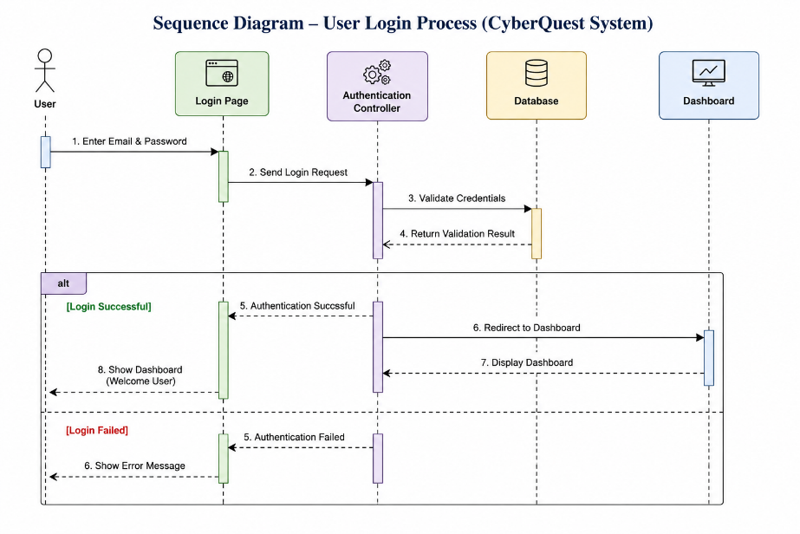

Fig 3.2.3 Sequence Diagram

- Activity Diagram
Start
- The user accesses the CyberQuest platform.
- The system displays the welcome page.
User Registration
- New users provide registration details.
- User information is stored in the database.
User Login
- Registered users enter their email and password.
- The system verifies the credentials.
Credential Validation
- The entered login details are checked against database records.
- Invalid credentials generate an error message.
Dashboard Access
- After successful login, the user is redirected to the dashboard.
- Available quiz options are displayed.
Quiz Selection
- The user selects a cybersecurity quiz.
- The selected quiz is loaded by the system.
Quiz Assessment
- Questions are displayed to the user.
- The user answers and submits the quiz.
Score Evaluation
- The system evaluates user responses.
- Scores are calculated automatically.
Results and Feedback
- Quiz results and feedback are displayed.
- Performance information is generated.
Performance Dashboard
- User scores and performance levels are shown.
- Progress can be monitored through the dashboard.
Logout
- The user exits the system securely.
- The session is terminated.
End
- The CyberQuest workflow is completed successfully.

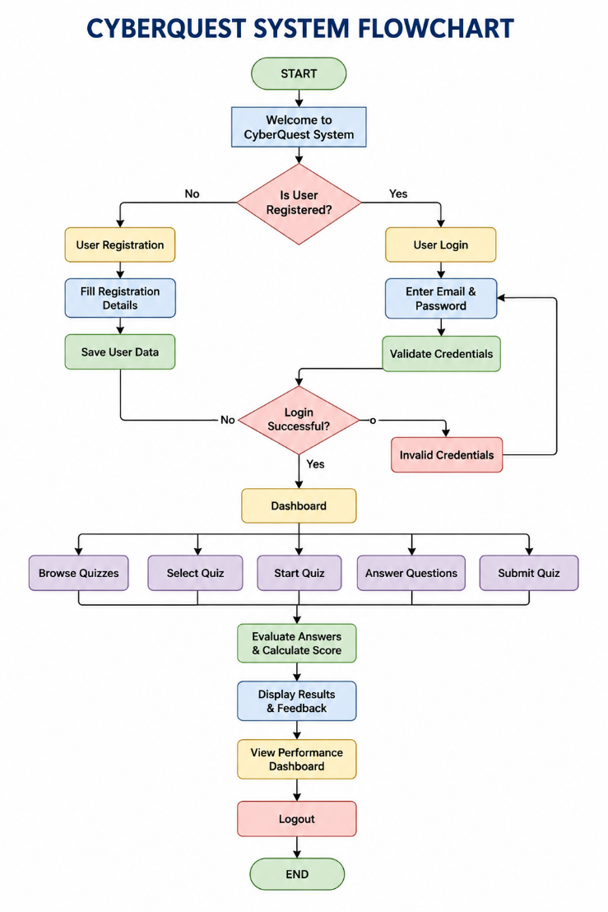
Fig 3.2.4 Activity Diagram

CHAPTER-4
IMPLEMENTATION
4.1 ENVIRONMENT SETUP
The development environment for CyberQuest was configured to support the design, development, and deployment of a web-based cybersecurity learning platform. The project was developed using modern web technologies and tools to ensure efficient performance, scalability, and ease of maintenance.
The frontend of the application was developed using HTML, CSS, and JavaScript, while the backend was implemented using Node.js and Express.js. MongoDB was used as the database for storing user information, quiz questions, and performance records. The application was developed and tested using Visual Studio Code and executed through a web browser.
4.1.1 Development Environment
- Operating System : Windows 10 / Windows 11
- Frontend : HTML,CSS, Java script
- Backend : node.js , express.js
- Database : MonogoDB
- IDE : Visual studio code
- Browser : Goggle chrome / Microsoft edge
- Version Control : Git
- Runtime environment : Node.js
Setup Steps:
Step 1: Install Node.js and npm on the system.
Step 2: Create a new project folder named CyberQuest.
Step 3: Initialize the Node.js project using npm init.
Step 4: Install required packages such as Express.js, Mongoose, and other dependencies.
Step 5: Install and configure MongoDB for database management.
Step 6: Create frontend pages using HTML, CSS, and JavaScript.
Step 7: Develop backend functionalities using Node.js and Express.js.
Step 8: Establish connection between the application and MongoDB database.
Step 9: Implement user authentication, quiz management, and score calculation modules.
Step 10: Run the application and test all functionalities through a web browser.
Step 11: Verify database operations and result generation.
Step 12: Deploy and maintain the application for end users.
4.2 IMPLEMENTATION OF MODULES
User Registration Module
This module allows new users to create an account by entering their details. The information is validated and stored securely in the MongoDB database.
User Login Module
This module verifies user credentials and provides secure access to the CyberQuest platform. Only authenticated users can access quiz functionalities.
Quiz Module
This module displays cybersecurity-related questions to users. Users can attempt the quiz and submit their answers for evaluation.
Score Calculation Module
This module evaluates the submitted answers and calculates the final score based on the number of correct responses.
Results Module
This module generates and displays quiz results along with the user's performance details after quiz completion.
Database Management Module
This module manages the storage and retrieval of user information, quiz questions, scores, and performance records using MongoDB.
4.3 INTEGRATION AND DEVELOPMENT
Development
The CyberQuest platform was developed using HTML, CSS, JavaScript, Node.js, Express.js, and MongoDB.
Integration
The frontend, backend, and database modules were integrated to ensure seamless communication and functionality.
Testing and Refinement
The application was tested to verify functionality, performance, and data accuracy
CHAPTER-5
EVALUATION
5.1 MODULES
The CyberQuest platform consists of several functional modules that work together to provide secure access, quiz management, performance evaluation, and data management services.
Authentication Module
This module verifies user credentials and ensures secure access to the platform.
Access Control Module
This module manages user permissions and restricts unauthorized access to system resources.
Quiz Management Module
This module handles quiz creation, question presentation, and answer submission processes.
Performance Evaluation Module
This module evaluates user responses and generates scores based on quiz performance.
Reporting Module
This module displays results, performance summaries, and user progress information.
Database Management Module
This module stores and manages user accounts, quiz questions, and performance records.
5.2 EVALUATION METRICS
- Measures the correctness of quiz evaluation and score generation.
- Measures the ability of the system to operate consistently without errors.
- Evaluates the effectiveness of user authentication and data protection mechanisms.
- Measures system response time and processing efficiency.
- Evaluates the ease of navigation and user interaction within the platform.
- Measures the system's ability to support increasing numbers of users and quizzes.
5.3 TEST CASES

Requirement Analysis
Understand all modules of the system:
- Identified the functional and non-functional requirements.
- Analyzed user and system expectations.
- Defined project objectives and scope.

Test Planning
- Prepared the project development plan.
- Defined module implementation strategy.
- Allocated resources and timelines.

Test Case Design
- Designed test cases for all modules.
- Defined expected outputs for each case.
- Verified functionality and performance requirements.

Test Environment Setup
- Configured Node.js development environment.
- Established MongoDB database connection.
- Prepared tools for testing and execution.

Login Module
- Verified valid user login functionality.
- Tested invalid credential handling.
- Ensured secure authentication process.

Registration Module
- Verified user registration process.
- Tested input validation mechanisms.
- Confirmed successful database storage.

Dashboard Module
- Verified dashboard accessibility.
- Tested display of user information.
- Ensured smooth navigation between modules.

Quiz Module Testing
- Verified question display functionality.
- Tested answer submission process.
- Confirmed proper quiz execution.

Score Calculation Testing
- Verified score generation accuracy.
- Tested evaluation of user responses.
- Confirmed result calculation process.
Database Module Testing
- Tested data storage operations.
- Verified data retrieval functionality.
- Ensured database consistency and integrity.
Security Testing
- Verified user authentication mechanisms.
- Tested protection of user information.
- Ensured secure access to resources.

Bug Reporting
- Analyzed reported issues.
- Implemented corrective actions.
- Verified successful resolution of defects.

Bug Fixing & Retesting
- Analyzed reported issues.
- Implemented corrective actions.
- Verified successful resolution of defects.

Final Testing
- Tested complete system functionality.
- Verified module integration.
- Ensured system readiness for deployment.

Test Closure
- Reviewed testing activities.
- Documented final test results.
- Confirmed successful project completion.

Cyber Quest Welcome Module

Introduction
The Home Page serves as the entry point of the CyberQuest platform and provides users with an overview of the application.

Objective
To introduce the platform and allow users to access the cybersecurity learning environment.

Working Process

Step 1: The user opens the Cyber Quest application.
Step 2: The system displays the Home Page with project information.
Step 3: The user clicks the Get Started button.
Step 4: The system redirects the user to the next page for further interaction.

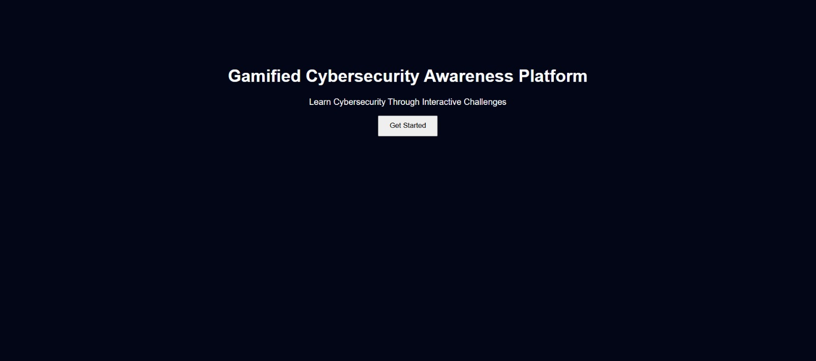

User Registration Module

Introduction
The User Registration Module allows new users to create an account and access the CyberQuest platform.

Objective
The objective of this module is To collect user information and create a secure account for platform access.

Working Process
Step 1: The user enters a username, email address, and password.
Step 2: The system validates the entered information.
Step 3: The user clicks the Register button.
Step 4: The system stores the user details in the database.
Step 5: The account is successfully created and the user can proceed to login



User Authentication Module

Introduction
The User Authentication Module allows registered users to securely access the CyberQuest platform using valid login credentials.

Objective
The objectives of this module are:
- To verify the identity of registered users.
- To provide secure access to the CyberQuest platform.
- To prevent unauthorized access to system resources

Working Process
Step 1: The user enters the registered email address and password.
Step 2: The system validates the entered credentials.
Step 3: The user clicks the Login button.
Step 4: The system authenticates the user information.
Step 5: Upon successful authentication, the user is redirected to the dashboard.


Cybersecurity Quiz Assessment Module

Introduction

The Cybersecurity Quiz Assessment Module presents cybersecurity-related questions to users and evaluates their knowledge through interactive assessments.

Objective
The objectives of this module are:
- To assess users' cybersecurity awareness and knowledge.
- To provide an interactive learning experience.
- To improve understanding of cybersecurity concepts.

Working Process
Step 1: The system displays cybersecurity quiz questions.
Step 2: The user selects answers for each question.
Step 3: The user reviews the selected responses.
Step 4: The user clicks the Submit Quiz button.
Step 5: The system forwards the responses for evaluation and score calculation.
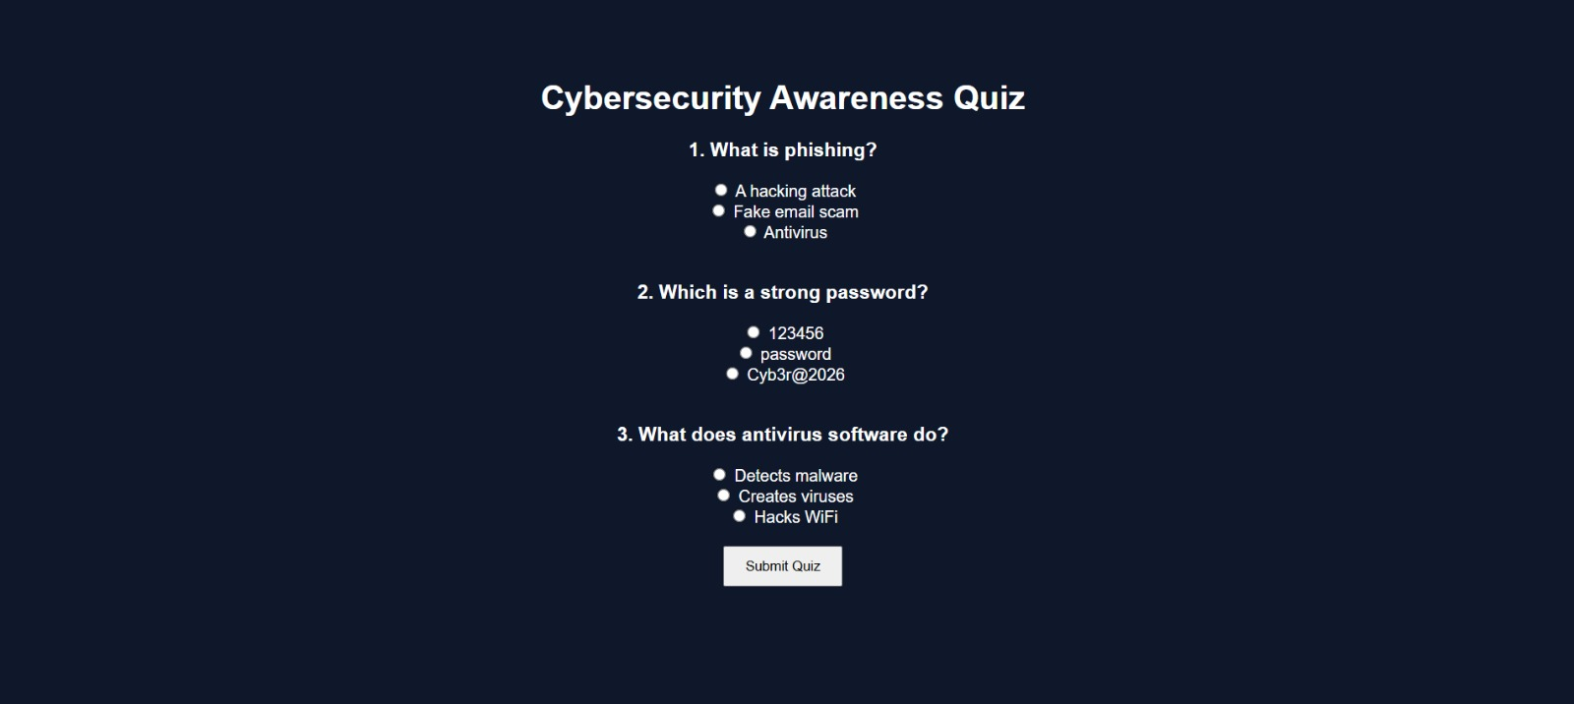

Performance Evaluation and Result Module

Introduction

The Performance Evaluation and Result Module calculates the user's score and displays the final quiz outcome after successful submission.

Objective
The objectives of this module are:
- To evaluate user responses accurately.
- To generate and display quiz scores.
- To provide feedback on user performance.

Working Process
Step 1: The system receives the submitted quiz responses.
Step 2: The answers are compared with the correct answers.
Step 3: The total score is calculated automatically.
Step 4: The final result and score are displayed to the user.
Step 5: The user can retry the quiz or logout from the platform.
.

User Performance Monitoring Module
Introduction
The User Performance Monitoring Module enables users to view their quiz scores, performance level, and overall learning progress on the Cyber Quest platform.
Objectives
- To display user performance and score details.
- To monitor learning progress and improvement.
- To provide access to quiz and account functionalities.

Working Process
Step 1: The user logs into the CyberQuest platform.
Step 2: The system retrieves the user's performance data from the database.
Step 3: The dashboard displays the user's score and performance level.
Step 4: The user can start a new quiz to improve performance.
Step 5: The user can logout from the platform when required.
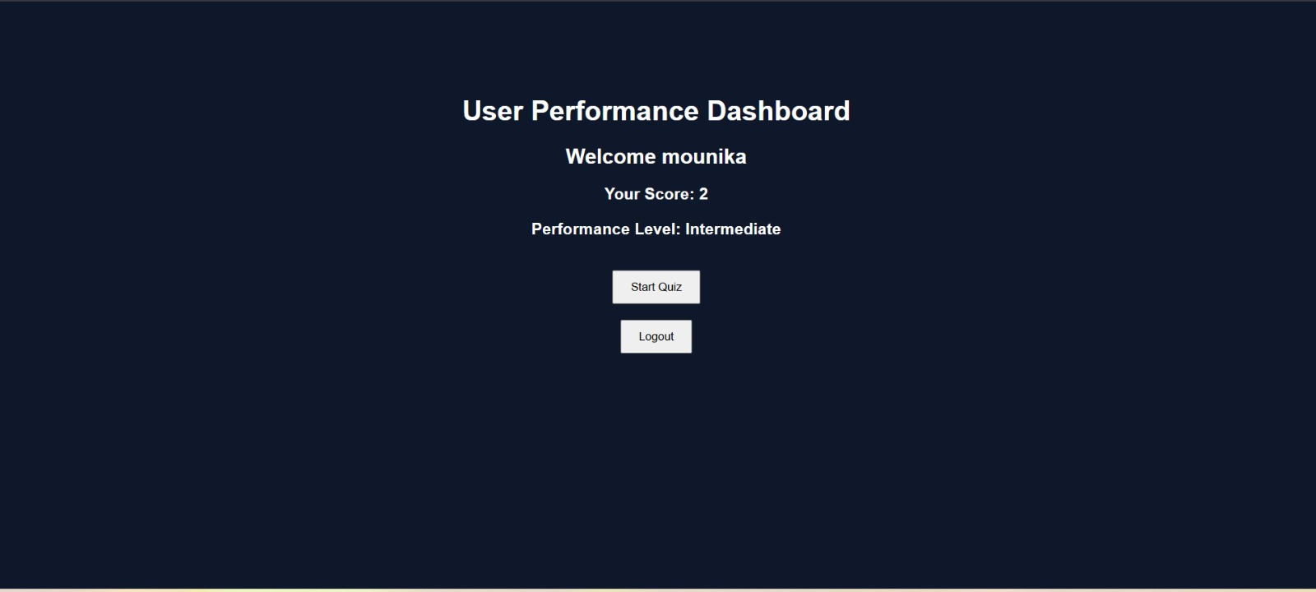

5.4 RESULTS

The CyberQuest platform was successfully developed and implemented to provide an interactive cybersecurity learning environment. The system enables users to register, log in, participate in cybersecurity quizzes, view their scores, and monitor their performance through a user-friendly dashboard.

Results Obtained
- Successful user registration and authentication were achieved.
- Cybersecurity quiz questions were displayed correctly.
- User responses were processed efficiently.
- Accurate score calculation was performed after quiz submission.
- Quiz results were generated and displayed successfully.
- User performance levels were monitored through the dashboard.
- Secure storage and retrieval of data were achieved using MongoDB.
- Smooth integration of frontend, backend, and database modules was accomplished.
- The platform provided an interactive learning experience for users.
- The system met the objectives of enhancing cybersecurity awareness and knowledge assessment..

CHAPTER 6
CONCLUSION AND FUTURE ENHANCEMENT
CONCLUSION:
The Cyber Quest: A Gamified Cybersecurity Learning and Assessment Platform was successfully designed and implemented to enhance cybersecurity awareness through interactive learning and assessment techniques. The platform provides users with a secure and user-friendly environment where they can register, log in, participate in cybersecurity quizzes, and evaluate their knowledge through instant feedback and performance tracking.
The system effectively combines educational content with gamification elements, making cybersecurity learning more engaging and accessible. By covering important topics such as phishing, malware, password security, and online safety, the platform helps users develop essential cybersecurity skills required in today's digital world. The successful integration of HTML, CSS, JavaScript, Node.js, Express.js, and MongoDB ensured efficient system performance, secure data management, and reliable user interaction.
Overall, the project achieved its objective of promoting cybersecurity awareness and providing an interactive learning experience that encourages continuous knowledge improvement and responsible digital behavior.

Key Achievements:

The Cyber Quest platform successfully provides a secure environment for cybersecurity learning and assessment. It enables user authentication, quiz-based learning, score evaluation, and performance monitoring through an integrated web application. The project enhances cybersecurity awareness while offering an engaging and user-friendly learning experience.

Personalized Career Recommendation System
The system can be extended to provide personalized learning recommendations based on users' quiz performance and cybersecurity knowledge levels. It can suggest relevant topics, learning resources, and practice quizzes to help users strengthen weaker areas. Such a personalized learning approach can improve user engagement and enhance the overall effectiveness of cybersecurity education.
This heading is the closest equivalent to the sample report's "Personalized Career Recommendation System" but adapted to your CyberQuest project.

Integration of EAPCET Rank Analysis
The project implemented an EAPCET rank-based prediction mechanism that assists students in identifying suitable colleges and academic opportunities. This reduces confusion during admission and counseling processes.

Development of Interest and Skills Assessment Module
An interactive assessment module was developed to evaluate:
- Student interests
- Problem-solving abilities
- Technology preferences
- Analytical thinking skills
The collected information improves recommendation accuracy.

FUTURE ENHANCEMENTS:
The platform can be enhanced by incorporating AI-based adaptive learning and personalized quiz recommendations based on user performance. Additional features such as leaderboards, achievement badges, real-time cybersecurity simulations, and mobile application support can further improve user engagement. Integration with advanced analytics and learning resources can make the system more effective for cybersecurity education and skill development.
Advanced features such as adaptive learning paths, AI-driven question generation, achievement badges, leaderboards, and real-world cybersecurity simulations can significantly improve user engagement and knowledge retention. These enhancements will make the platform more effective in promoting cybersecurity awareness and skill development.
REFERENCES
[1] Ian Goodfellow, Yoshua Bengio, and Aaron Courville, Deep Learning, MIT Press, 2016.
[2] William Stallings, Network Security Essentials: Applications and Standards, Pearson Education, 6th Edition, 2017.
[3] Charles P. Pfleeger and Shari Lawrence Pfleeger, Security in Computing, Pearson Education, 5th Edition, 2015.
[4] Nina Godbole and Sunit Belapure, Cyber Security: Understanding Cyber Crimes, Computer Forensics and Legal Perspectives, Wiley India, 2011.
[5] Node.js Documentation, Available at: https://nodejs.org/docs
[6] Express.js Documentation, Available at: https://expressjs.com
[7] MongoDB Documentation, Available at: https://www.mongodb.com/docs
[8] MDN Web Docs – HTML, CSS and JavaScript Reference, Available at: https://developer.mozilla.org
[9] OWASP Foundation, Web Application Security Guidelines, Available at: https://owasp.org
[10] National Institute of Standards and Technology (NIST), Cybersecurity Framework, Available at: https://www.nist.gov/cyberframework
[11] Cisco Networking Academy, Introduction to Cybersecurity, Available at: https://www.netacad.com
[12] EC-Council, Cybersecurity Learning Resources and Ethical Hacking Concepts, Available at: https://www.eccouncil.org
[13] Journal of Cybersecurity, Oxford University Press, Available at: https://academic.oup.com/cybersecurity
[14] International Journal of Information Security, Springer Publications.
[15] Research Papers and Articles on Cybersecurity Awareness, Gamification, and Online Learning Systems from IEEE Xplore Digital Library.

APPENDIX AND SAMPLE CODE
A.1 DATASET / USER DATA DESCRIPTION
The CyberQuest platform uses a collection of cybersecurity-related questions and user information for quiz assessment and performance tracking.
User Dataset
The user dataset contains:
- Username
- Email Address
- Password (Encrypted)
- Quiz Score
- Performance Level
- Quiz Attempts
Quiz Dataset
The quiz dataset contains:
- Question ID
- Question Text
- Multiple Choice Options
- Correct Answer
- Cybersecurity Category
- Difficulty Level (if applicable)
The dataset is stored in MongoDB and is used for authentication, quiz management, and performance evaluation.

A.2 SYSTEM MODULES / ARCHITECTURE

System Modules
The CyberQuest platform follows a client-server architecture consisting of a frontend developed using HTML, CSS, and JavaScript, a backend implemented using Node.js and Express.js, and a MongoDB database for data storage and management. The architecture enables secure authentication, efficient quiz processing, and real-time result generation.

1. Cybersecurity Awareness Landing Module
This module serves as the entry point of the platform and provides users with information about the CyberQuest system.
Functions:
- Provides an introduction to the CyberQuest platform and its features.
- Allows users to navigate to registration and login services.
Input: EAPCET Rank
Output: Validated rank data

2. User Registration Module
This module allows new users to create an account and securely store their information in the database.
Functions:
- Collects user information required for account creation.
- Stores user details securely in the MongoDB database.
Input: User responses
Output: Skill assessment data

3. User Authentication Module
This module verifies user credentials and provides secure access to the platform.
Functions:
- Verifies user credentials during login.
- Ensures secure access to authorized users only.

4. Cybersecurity Quiz Assessment Modul
This module displays cybersecurity questions and records user responses for evaluation.
Functions:
- Displays cybersecurity-related quiz questions to users.
- Records and processes user responses for evaluation.
Output Example: Data Science, Cloud Engineer, Cybersecurity Analyst

Performance Evaluation and Result Module
This module calculates scores, evaluates quiz responses, and generates user results.
Functions:
- Calculates quiz scores based on correct answers.
- Generates and displays performance results to users.

User Performance Monitoring Module
This module displays user scores, performance levels, and learning progress through the dashboard.
Functions:
- Tracks user progress and quiz performance.
- Displays score history and performance levels through the dashboard.
7 Database Management Module
This module manages the storage and retrieval of user records, quiz questions, and performance data using MongoDB.
FUNCTIONS:
- Stores user information, quiz questions, and results.
- Retrieves and updates data whenever required by the system.
A.3 TRAINING AND EXECUTION SETUP
The training setup involves preparing quiz datasets, user data management, and configuring the system components required for application execution. Cybersecurity questions and answers are collected, validated, and stored in the MongoDB database for assessment purposes.

Training Setup
Step 1: Data Collection
- Collect cybersecurity-related questions from reliable learning resources.
- Organize questions into different cybersecurity categories.
Step 2: Data Preparation
- Structure questions, options, and correct answers.
- Prepare datasets for database storage.
Step 3: Data Validation
- Verify question accuracy and answer correctness.
- Remove duplicate or invalid entries.
Step 4: Database Integration
- Store validated quiz data in MongoDB.
- Establish connections between the application and database.
Step 5: System Configuration
- Configure frontend and backend modules.
- Prepare the application for execution and testing.

Execution Setup
Hardware Requirements
- Processor: Intel Core i3 / Intel Core i5 or equivalent
- RAM: 4 GB Minimum, 8 GB Recommended
- Storage: 50 GB Free Disk Space
- System Type: 64-bit Operating System
- Internet Connection: Required for database connectivity and application access
Software Requirements
- Operating System: Windows 10 / Windows 11
- Frontend: HTML, CSS, JavaScript
- Backend: Node.js, Express.js
- Database: MongoDB
- IDE: Visual Studio Code
- Browser: Google Chrome / Microsoft Edge
- Runtime Environment: Node.js

Execution Steps
Step 1: Start the MongoDB database service.
Step 2: Launch the Node.js server.
Step 3: Open the application in a web browser.
Step 4: Register or log in to the platform.
Step 5: Attempt cybersecurity quizzes and submit responses.
Step 6: View results and monitor performance through the dashboard.

Execution Flow
User Login → Quiz Assessment → Answer Evaluation → Score Generation → Performance Analysis → Results → Dashboard
A.4 DEPLOYMENT DETAILS
The CyberQuest platform was deployed in a web-based environment to provide users with secure access to cybersecurity learning and assessment services.

Deployment Environment
- Frontend: HTML, CSS, JavaScript / React ,Goggle chrome,vs code
- Backend: Node.js , express.js,npm , vs code
- Database: MongoDB ,mongoose ODM

Deployment Steps
Step 1: Install Node.js and MongoDB.
Step 2: Configure database connectivity.
Step 3: Install project dependencies using npm.
Step 4: Start the MongoDB database service.
Step 5: Launch the Node.js server.
Step 6: Open the application through a web browser.
Step 7: Verify user registration, login, and quiz functionalities.
Step 8: Monitor application performance and database operations.

Deployment Features
- Secure user authentication and access control.
- Interactive cybersecurity quiz assessment.
- Automated score calculation and result generation.
- User performance monitoring dashboard.
- Efficient MongoDB-based data management.
- Responsive and user-friendly web interface

A.5 RESULTS
- The Cyber Quest platform was successfully developed and implemented.
- User registration and authentication functionalities worked correctly.
- Cybersecurity quizzes were displayed and executed successfully.
- User responses were evaluated accurately by the system.
- Scores were generated automatically after quiz submission.
- Performance results were displayed through the user dashboard.
- MongoDB successfully stored and retrieved user and quiz data.
- Frontend, backend, and database integration functioned efficiently.
- The system provided an interactive cybersecurity learning experience.
- The project successfully achieved its objective of improving cybersecurity awareness and knowledge assessment.
A.6 BENEFITS OF THE SYSTEM
- Enhances users' understanding of cybersecurity concepts.
- Provides a user-friendly and interactive learning experience.
- Enables quick assessment of cybersecurity knowledge.
- Offers instant score calculation and result generation.
- Tracks user performance and learning progress effectively.
- Supports secure data storage and management using MongoDB.
- Encourages continuous learning through self-assessment.

